**Name – Ashish Vijay Borate**

**Management for Demand Paging in Linux: Improving Memory Efficiency.**

**An introduction:** With the wide variety of operating systems on offer, efficient memory management is a must for optimal performance. A crucial method in this sector is demand paging. During this article, we will explore the concept of demand paging in Linux and its impact on memory usage, while also creating colorful diagrams to illustrate it more effectively.

**What is Demand Paging?**  
A memory management technique known as demand paging allows an operating system to load pages into memory only when they are required by the program during execution. This is different from the traditional method of loading entire programs into memory at the beginning, although some parts may never be used.

In what way does Demand Paging work: Using a colorful diagram, we can illustrate the demand paging process.

**How Demand Paging Works:** Let’s illustrate the process of demand paging with a colorful diagram.

1. **Initial State:**
   * Initially, only a small portion of the program is loaded into memory.
   * The rest of the program remains on disk.
2. **Page Demand:**
   * As the program executes, it requests additional pages.
   * These pages are then brought into the main memory from the disk.
3. **Page Replacement:**
   * If the available memory is full, the system needs to choose which pages to keep and which to replace.
   * This involves swapping out less frequently used pages to make room for new, demanded pages.

**Advantages of Demand Paging:**

1. Efficient Memory Utilization: Demand paging guarantees that simplest the necessary pages are loaded, lowering needless reminiscence consumption. This leads to better ordinary system performance.
2. Faster Program Start-Up: Programs begin more quick because handiest the important pages are loaded initially. Less I/O operations are wished, improving the overall performance.
3. Increased Multitasking Capability: Demand paging allows higher guide for multitasking, as the working gadget can manage reminiscence assets greater flexibly.

**Challenges and Solutions:**

1. Page Faults: When a program accesses a web page no longer presently in memory, a page fault takes place. While page faults can introduce overhead, efficient algorithms for web page alternative can minimize their impact.
2. Optimizing Page Replacement Algoriths: Various algorithms, together with the Least Recently Used (LRU) or Clock algorithm, are employed to optimize the web page replacement system.

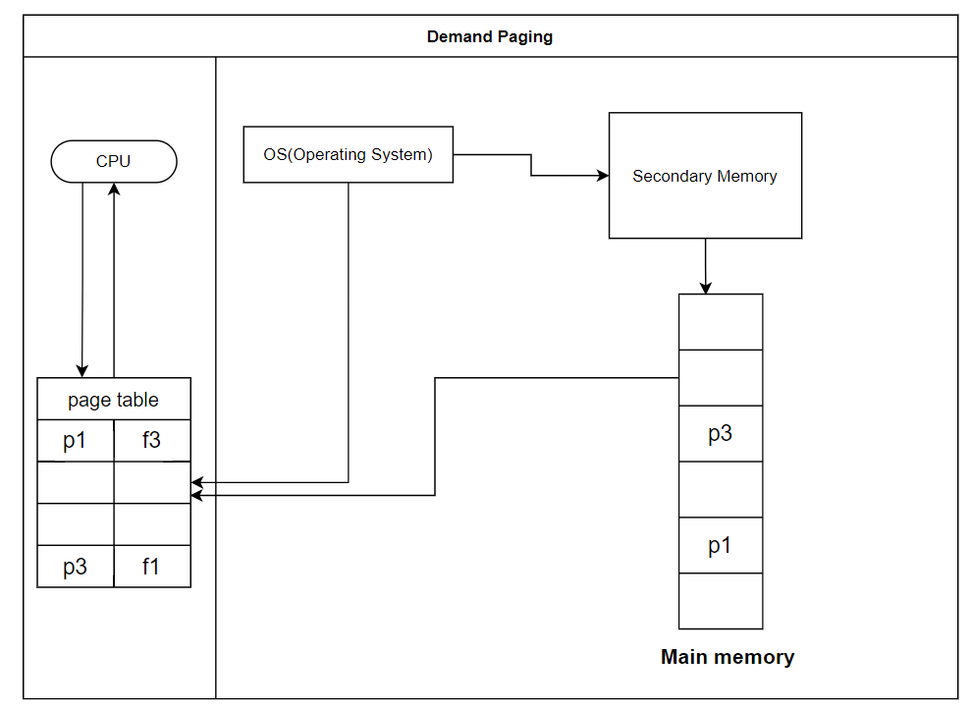

**conclusion**

In conclusion, demand paging is an essential idea in contemporary operating systems and is critical to memory optimization. Operating systems like Linux can accomplish effective multitasking, faster program starts, and overall enhanced system performance by loading only the necessary pages into memory as needed. As we've shown with our vibrant graphics, demand paging is made easier to understand and more approachable for both readers and learners by its visual portrayal. Gaining an understanding of demand paging helps one to comprehend the complex interplay between hardware and software that maintains our systems operating efficiently.